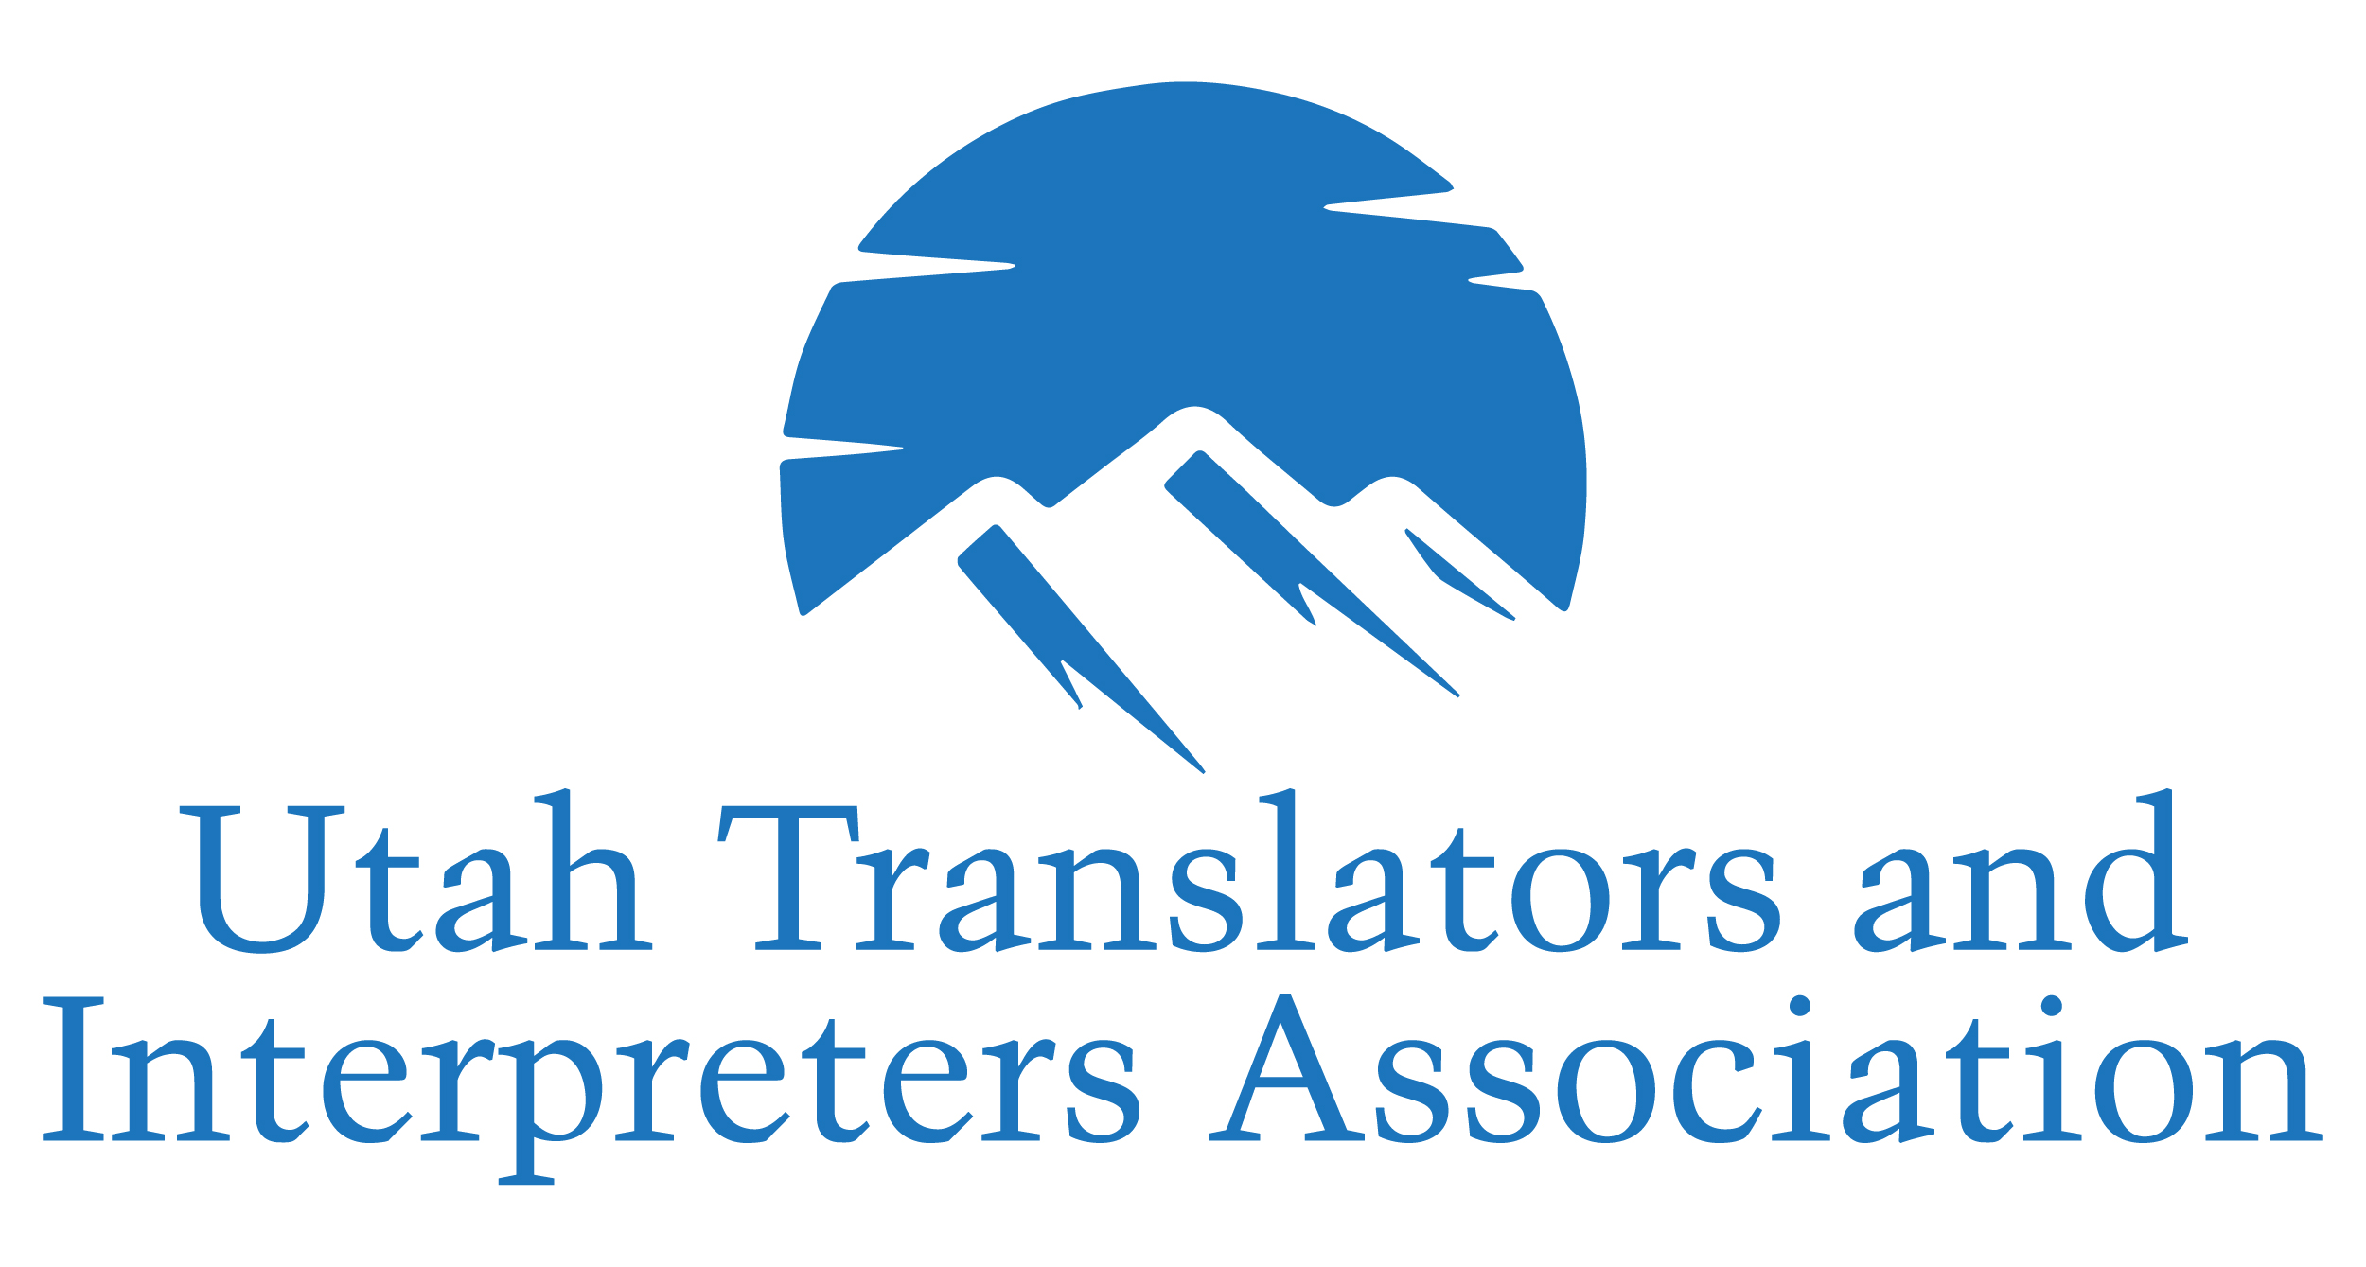

The Conference Committee & UTIA

Present the
Utah Language Access Conference
Equity, Innovation, Empowerment
May 15 - 16, 2020
University of Utah Health
26 2000 E Salt Lake City Utah 84113

_{[Your Event Name]}
2020 Sponsor & Exhibitor Prospectus

Join us and Reserve your space

today!

EMAIL: secretary@utianet.org

Call: (801) 494-7058

The Conference Committee & UTIA
Present the
2020 Utah Language Access Conference
Equity, Innovation, Empowerment
May 15 - 16, 2020
University of Utah Health
26 2000 E Salt Lake City Utah 84113

2020 Sponsor & Exhibitor Prospectus
About the Utah Language Access Conference
The Utah Language Access Conference is a joined effort from key stakeholders in language access and interpretation in the state of Utah, coming from varied organizations and industry backgrounds, including interpreters, trainers, Language Services managers, and translators. The Utah Translators and Interpreters Association (UTIA) is a non-profit organization comprised of, and formed by, language professionals in the state of Utah. UTIA’s goal is to advance and elevate the quality and availability of language services in Utah, and work for the development of our profession.
Our conference is intended to provide an educational and networking opportunity for interpreters and translators working in the medical, legal, and educational fields. Interpreters, translators, trainers, hospital administrators, compliance officers, language program coordinators, industry leaders, and healthcare/services providers from Utah and other states around the country are invited to gather for two days to share their knowledge and experience, and enhance skills, new learn about policy trends, and other emerging topics affecting language services in the healthcare, legal, and education fields. Our conference attracts both spoken language and ASL interpreters.
We emphasize the importance of trained and qualified interpreters as facilitators of communication both in the legal system, and the patient-centered communication in the health care system. The Utah Language Access Conference supports the professional goals of interpreters and translators, and embraces the opportunity to offer Continued Education Units (CEU).

Why Participate as a Sponsor/Exhibitor?
The first Utah Language Access Conference in 2018 was a great success, with 156 attendees from 8 different states. On our second year (ULAC19) we saw over 300 attendees over the two-day event. This year we hope to host a larger group of interpreters and translators. As one of very few states in the nation with a State Certification program for both ASL and spoken language medical interpreters, industry leaders from around the country look to Utah for direction and inspiration, and you can share that spotlight by being part of this event. Linguists are eager to expand their careers, and looking for agencies, educators and industry leaders who support their goals.
The Utah Language Access Conference will serve as a rich and engaging gathering place for interpreters, interpreting students, translators, patient advocates, and medical staff to support each other in their shared goal of improving communication skills, access to services, quality and fairness in the industry.
Your sponsorship will allow you to reach our interpreting and translating community, and help keep our conference affordable and accessible!

What do we offer?
- Full-day exhibit hours with dedicated time in the program for attendees to focus solely on learning about your product/services.
- Specific activities scheduled to maximize traffic flow and focus on brand awareness and product demonstrations.
- Specific networking activities to drive traffic to your table.
- Increasing your online presence through listing your company on the UTIA website and the Conference’s social media.
- Access to advocates, decision makers or influencers for services and programs.
- Among attendees will be managers and those in charge of departmental budgets or vendor contracts for their hospitals.
- Many attendees will come from the largest healthcare systems and Integrated Delivery Networks in the state.
- Sponsors and Exhibitors are welcome to all member networking events to build relationships with all prospects and customers.

We do not want you to miss out on this event to include your organization’s products, programs and services to buyers and influencers, or talent recruitment for your organization!
Our Conference Committee is organizing several activities designed to ensure traffic throughout the exhibit area to ensure networking and introduction opportunities.
To reserve your spot and level of sponsorship, complete the enclosed registration form. Contact secretary@utianet.org for any questions.

The Conference Committee & UTIA
Present the
2020 Utah Language Access Conference
Equity, Innovation, Empowerment
May 15 - 16, 2020
University of Utah Health
26 2000 E Salt Lake City Utah 84113

2020 PROMOTIONAL OPPORTUNITIES
Diamond Sponsor (1 available) $3,000
The Diamond Sponsor has optimal presence and visibility at the Utah Language Access Conference. This sponsorship offers unique pre- and post-conference visibility. Your Sponsorship includes the following:
- Five-minute address and introducing the keynote speaker on either Friday or Saturday (text approved by the Conference Committee).
- Special recognition as sponsor of the reception networking event on Friday evening.
- 4 conference registrations (a $320+ value!).
- One exhibit space with table (a $300 value!) with prominent placement.
- A one-year corporate membership to UTIA (a $150 value)
- A one-time e-blast promotional message to registered attendees.
- Distribution of two promotional items in attendee welcome package.
- Sponsor listed on all conference publicity.
- Organization mention at all Conference communications and prominent logo placements with acknowledgement in all promotional materials.
- Social media acknowledgement.

Gold Sponsor (3 available) $2,000
The Gold Sponsor has optimal presence and visibility at the Utah Language Access Conference. This sponsorship offers unique pre- and post-conference visibility. Your Sponsorship includes the following:
- Five-minute address to attendees prior to keynote address on either Friday or Saturday (text approved by the Conference Committee).
- 3 conference registrations (a $240+ value!).
- One exhibit space with table (a $300 value!) with prominent placement.
- A one-year corporate membership to UTIA (a $150 value)
- A one-time e-blast promotional message to registered attendees.
- Distribution of two promotional items in attendee welcome package.
- Sponsor listed on all conference publicity.
- Organization mention at all Conference communications and prominent logo placements with acknowledgement in all promotional materials.
- Social media acknowledgement.

Silver Sponsor $1,000
Silver Sponsors are those high-level sponsors who desire to have high visibility and a strong presence at the Conference. Your Sponsorship includes the following:
- 2 conference registrations (a $160+ value!).
- One exhibit space with table (a $300 value!) with prominent placement.
- A one-year corporate membership to UTIA (a $150 value)
- Distribution of one promotional items in attendee welcome package.
- Sponsor listed on all conference publicity.
- Organization mention at all Conference communications and prominent logo placements with acknowledgement in publications.
- Social media acknowledgement.

Bronze Sponsor $500
Bronze Sponsors are those sponsors who desire to have a participating presence and visibility at the Utah Language Access Conference. Your Sponsorship includes the following:
- One full conference registrations (an $80+ value!).
- One exhibit space with table (a $300 value!).
- Prominent signage with logo during coffee breaks, breakfast and lunch.
- Sponsor listed on all conference publicity.
- Organization mention at all Conference communication and prominent logo placements in all publications.
- Social media acknowledgement.

Exhibitor
- Exhibitors will each receive name recognition in the conference online program and will be listed on the conference social media webpage. Exhibitors receive one conference registration (an $80 value!). Each exhibit comes with a 6-foot table and one chair. Internet Wi-Fi is available in the exhibit hall at no additional charge. High attendee traffic to your table is guaranteed by our raffle entry form that must be signed by each exhibitor in order to be eligible to win prizes!
- Exhibitor (includes 1 conference registration – an $80+ value!) $300

Promo Table
Promo tables allow your organization to participate with our conference without the cost of sending a representative. Send us your print handouts and promotional items, we’ll place them on a table for you and refresh them throughout the event. Promo tables will be located in the exhibit hall, where attendees will have access to your information during the entire conference. NOTE: Representatives from your organization may not actively network at Promo Tables. $150
In-Kind Donation
Organizations that are unable to attend the conference are welcome to support this event through in-kind, tax deductible donations. Organization name will be included in the conference online program.

Raffle Prize Donation
UTIA will hold a raffle during the closing ceremony of the conference. Your donated gift adds value to promoting your company. Raffle items are an incentive to attending the conference, increasing the potential number of contacts for you. Organization name and raffle prize will be included in the conference online program and publicized via email and social media.

Sponsor/Exhibitor Selection and Contact Information
Please complete this application and return electronically to secretary@utianet.org Questions? Contact Carlos Martinez-Morales, at (801) 494-7058. The deadline to appear in online and/or print publicity is Friday, April 15, 2020

- Contact Information PLEASE PRINT CLEARLY
Organization (Exactly as it is to be printed in all acknowledgments):
____________________________________________________________________________________
Primary Contact Name: ________________________________________________________________
Contact Title: ________________________________________________________________________
Address: ___________________________________________________________________________
City/State/Zip: _______________________________________________________
Phone/Fax: ___________________________________ E-mail: _______________________________
Website: ____________________________________________________________________________

Description of your services/products: ______________________________________________________

____________________________________________________________________________________
- Billing Information □ Same as Contact Information
Primary Contact Name: ________________________________________________________________
Contact Title: ________________________________________________________________________
Address: ___________________________________________________________________________
City/State/Zip: _______________________________________________________
Phone/Fax: ___________________________________ E-mail: _______________________________

- Sponsorship Packages: Price:
__ Diamond Sponsor (1 available) $3,000 (includes 4 registrations)
__ Gold Sponsor (3 available) $2,000 (includes 3 registrations)
__ Silver Sponsor (5 available) $1,000 (include 2 registrations)
__ Bronze Sponsor $500 (includes 1 registration)

- Exhibitor: Price:
__ Exhibit table (includes 1 registration) $300
__ Additional registration $80

- Promo Table: Price:
__ Promo table $150

- In-Kind Donation/Scholarship Fund
__ $80 towards registration for refugee participant
__ $100
__ $200
__ Other: ________________
Total sponsorship price: $ _________
Total exhibit price: $ _________
Additional registrations: Number of registrations _________ x $80 $ _________
Total promo table price: $ _________
In-kind donation: $ _________
GRAND TOTAL $ _________

- Raffle Prize
__ YES! We will donate a raffle prize for the closing ceremony.
Item Description (for program) : ________________________________________________ Value: _______
Attendee Badge Information (print clearly) Include email and languages spoken
See “Sponsorship Packages” and “Exhibitors” for number of Registrations
1. Name:
2. Name:
3: Name:
4: Name:
5: Name:
6: Name:
Payment Information
__ Online Payment (will receive a secured payment link or instructions to pay through utianet.org)
__Check# ____________ (Please make checks payable to UTIA, 160 E 6740 S Midvale, UT 84047)
Invoice me ___ Invoice Instructions ____________________________________________________

SPONSOR/EXHIBITOR TERMS OF AGREEMENT
The following rules and regulations have been designed for the benefit of all exhibitors and sponsors and, in conjunction with the application, constitute a formal agreement. The Utah Language Access Conference and UTIA requests full cooperation in the observance of these terms. UTIA reserves the right to terminate exhibitor or sponsor privileges at any time for breach of these rules and regulations. Expulsion of an exhibitor under these rules shall not give rise to a claim for a refund of the fees paid by such exhibitor.
1. EXHIBIT SCHEDULE (tentative)
Set up and tear down schedule will be provided
2. FAILURE TO OCCUPY SPACE
Space not occupied by 9:30 a.m. on May 15, 2020 will be forfeited by exhibitors and their space may be reassigned or used by the conference management without refund.
3. RATES, DEPOSITS AND REFUNDS
Exhibit space will be rented and sponsorships sold at the rates in accordance with the application form. No application will be processed or space assigned without payment. Exhibits must be fully paid for by April 15, 2020.
If assigned space is not paid for by this date, it may be reassigned at the discretion of conference management.
4. ARRANGEMENTS OF EXHIBITS
Any portion of an exhibit that obstructs the view, interferes with the privileges of other exhibitors, extends beyond the designated booth space or for any reason becomes objectionable, must be modified or removed by the exhibitor. The conference management reserves the right to inspect each booth prior to show opening.
5. EXHIBIT DESIGN
All exhibit space must be arranged and constructed in accordance with the provisions and limitations in the exhibitor application. If an exhibit fails to conform to the exhibitor application, it must be modified to comply or be removed.
6. SUBLEASING OF SPACE
Exhibitors may not assign, sublet or apportion to others the whole or any part of the space allocated, and may not display goods or services other than those produced or regularly distributed by them.
7. CONDUCT
All exhibits will be to serve the interest of the Utah Language Access Conference attendees and will be operated in a way that will not detract from other exhibits or the meeting as a whole.
8. SWEEPSTAKES, CONTEST OR ANY PROMOTION
Information will be provided
9. FIRE, SAFETY AND HEALTH
The exhibitor assumes all responsibility for compliance with local, city and state ordinances and regulations covering fire, safety and health. All exhibit equipment and materials must be located within the assigned space. NO combustible material will be stored in or around exhibit.
10. LIABILITY AND SECURITY
The Conference Committee and UTIA make no warranty, expressed or implied, that security measures will avert or prevent occurrences which may result in loss or damage. Each exhibitor must make provisions for the safeguarding of his or her goods, materials, equipment and display at all times. The Conference Committee and UTIA will not be liable for loss or damage to the property of exhibitors or their representatives from theft, fire, accident or other causes.
11. USE OF NAME & LOGO
You may not use the UTIA or the Utah Language Access Conference logo in the advertising or administration of any promotion which you provide without the express written permission of the UTIA or the Utah Language Access Conference Committee.
12. CONTACT
For questions or more information, please contact: secretary@utianet.org.

AGREEMENT SIGNATURE
Payment: Under the terms of this agreement, the exhibitor/sponsor agrees to pay 100% of the total fee with this application. Full payment must be received no later than April 15, 2020.
Cancellation Policy: Any exhibitor, sponsor or other participant who cancels exhibit space or sponsorship prior to April 1, 2020 shall receive a full refund, less a $100 administrative fee.
Any exhibitor/sponsor who cancels exhibit space or sponsorship between April 1 and April 20, 2020 will receive a 25% refund on any payments made. If cancellation in whole or part is made after April 20, 2020 the exhibitor / sponsor shall be liable to UTIA, as liquidated damages, for the entire unpaid balance of the total value of the exhibit or sponsorship cancelled.
Cancellation requests must be submitted to secretary@utianet.org.
If this application and agreement has not been received, properly signed, and accompanied by payment in full by April 15, 2020 it may be declared null and void so that exhibit space or sponsor benefits may be reassigned.
Acceptance of this agreement by UTIA constitutes a contract. We understand this application becomes a binding contract when signed by us and accepted by UTIA. We have read and agree to abide by all rules and regulations, as outlined in the application form and the exhibitor/sponsor terms of agreement.

____________________________________ _________________________________
(Please print name of individual) (Please print title of individual)
____________________________________ _________________________________
(Authorized Signature) (Date) (Organization Name)

